Lab Assignment 5

1) Implement Johnson’s algorithm for All-pairs shortest paths to find shortest paths between every pair of vertices in a given weighted directed Graph and weights may be negative.
Show the step by step procedure of finding the all-pairs shortest path of the following graph and compare it with the answer obtained using the program you implemented.
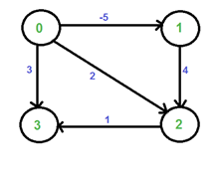
2) a) Apply the Floyd-Warshall algorithm to the graph in the following graph. Write a program to find the shortest path from A to H and display the initial values of the d(i, j), i, j = 1, 2, . . . , 9; the values after k = 1, k = 3, and k = 5; and the final values.

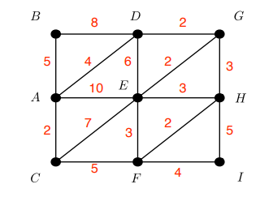
b) How can the output of the Floyd-Warshall algorithm be used to detect the presence of a negative-weight cycle? Explain your answer.

